Get Ready Before your Virtual Visit:
- If this is your first virtual visit, you will need to download and install the Zoom video application to your computer or smartphone before launching your visit. You can find the application for download in the Apple Store, Google Play, or directly from Zoom.

- If you plan to use a mobile device or tablet for your Virtual Visit, download the Partners Patient Gateway app. If you plan to use a Windows or Mac computer, please use Chrome, Firefox, or Safari to log in to Patient Gateway at the time of your virtual visit.

- Please log into patient gateway to access your virtual visit using the directions below at least 5 minutes before your scheduled appointment time.
You can also save time and eCheck-in before your appointment from your device or desktop! Go to https://mychart.partners.org/mychart-prd/Visits/visitslist and confirm your appointment.

How to Launch a Virtual Visit Using a Desktop Computer (Mac or Windows):
- Log in to the Partners Patient Gateway website on Safari, Google Chrome, or Firefox.
  - Log in to Patient Gateway with your username and password.
- Click on the 'Visits' button and then 'Appointments & Visits' button on the top menu bar.

- Look for your Virtual Visit Appointment scheduled for the specific date and time.
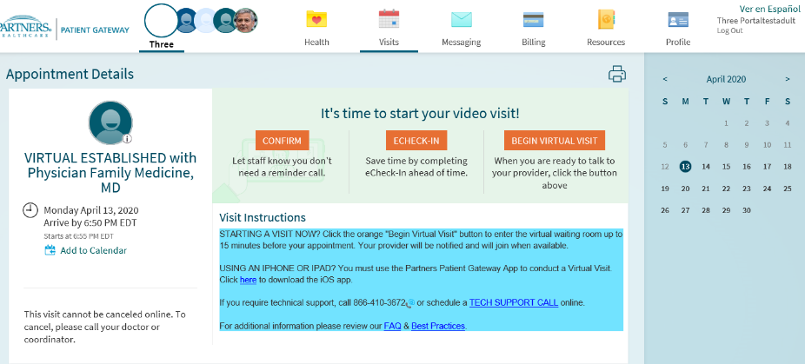
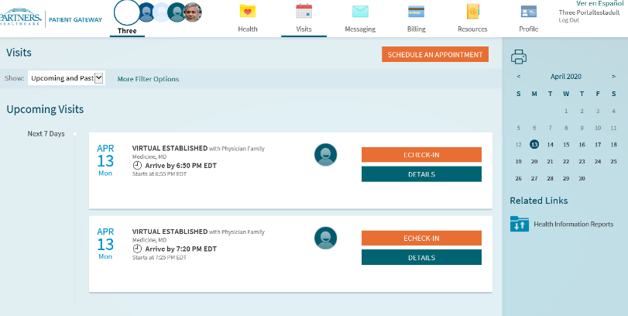
  - Click on the 'Details' button to open the appointment and then click the orange 'Begin Virtual Visit' button.
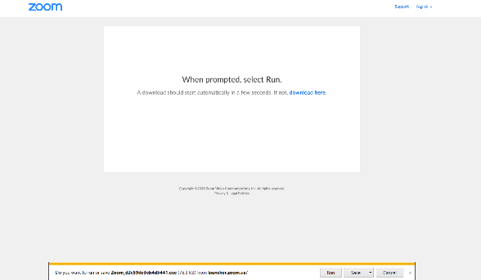

- If you haven’t already, you will be directed to download the video communication software Zoom to your desktop computer.
  - When prompted, select ‘run’ to begin installing.
Once completed, you will be brought to the Virtual Waiting Room. From here you should wait until your provider initiates the video with you through the app. When the video begins, you will be asked to click ‘Join with Computer Audio’ to start.
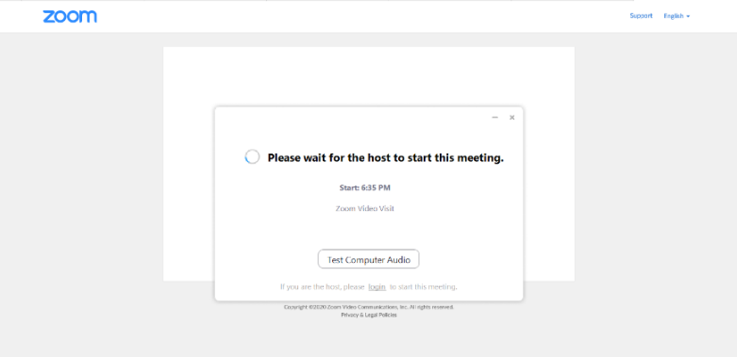

How to Launch a Virtual Visit Using a Mobile Device (iPad/iPhone (running on IOS 12.1 or later), Android phone/Tablet (running on 4 or later):
- Open your 'Partners Patient Gateway' app.
  - Log in to Patient Gateway with your username and password.
- Click on the 'Appointments' button and look for your Virtual Visit Appointment scheduled for the specific date and time. Click on the appointment to open it and then click the orange 'Begin Visit' button.
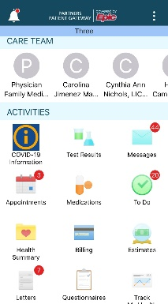
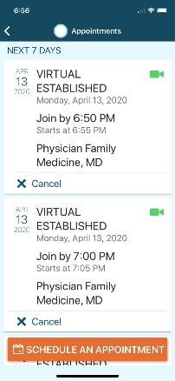
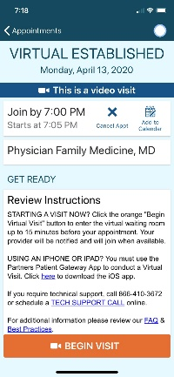

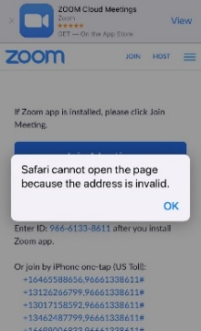
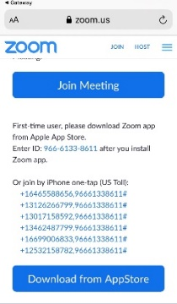
If the Zoom application does not load, select ‘ok’ and the ‘download app’ screen will appear. Download the Zoom app from the Apple Store or Google Store, and once that is downloaded go back to your Patient Gateway app and select ‘Begin Visit’.

It may ask if you want to open this out of Partners Patient Gateway to launch the video visit, if so click ‘continue’ and ‘confirm’. This should bring you to the Virtual Waiting Room. From here you should wait until your provider initiates the video with you through the app.

How to Launch a Virtual Visit Via Internet on a Mobile Device:
- Log in to the Partners Patient Gateway website on Safari, Google Chrome, or Firefox.
  - Log in to Patient Gateway with your username and password.
- Click on the 'Appointments' button and look for your Virtual Visit Appointment scheduled for the specific date and time. Click on the appointment to open it and then click the orange 'Begin Visit' button.
  - Note: Pop-up blocker appears if your mobile device is set to block pop-ups. Go to your device settings, to allow pop-ups. In iOS and Android, make sure you tap or swipe the green toggle to grey, so it is disabled.
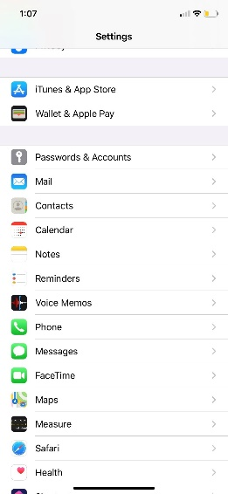
iOS Android
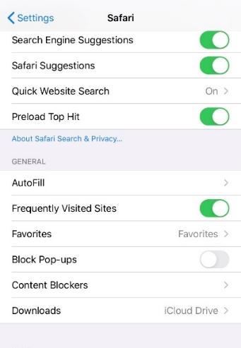
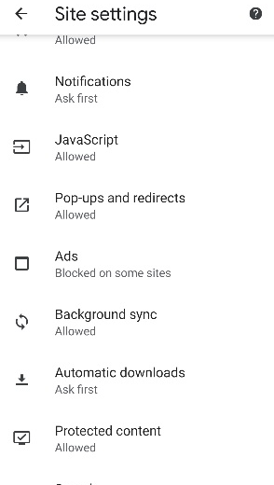

Best Practices for Using Your Computer:
• To have your computer run efficiently, it’s best to restart your computer. That way your computer is starting fresh.
• And close any unnecessary programs and applications. These take away from resources needed for your computer to run efficiently.
• Update your Computer regularly. There are updates that get sent to your computer from Windows, Apple or an application like Java or Adobe. Keeping these up to date will help the performance and compatibility of your computer.
• Know where your volume control is. That way you can adjust the volume to your liking or mute/unmute your speakers.
• Safari users: Enable pop-up windows. Open Preferences -> Security - > deselect Block pop-up windows.
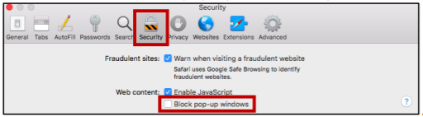

Best Practices for Using Your Webcam:
• You should be at least 3 feet back from the camera.
• Have your Shades drawn and avoid backlighting.
• Look at the camera when you are speaking instead of the Computer Monitor.
• To keep background noise to a minimum, close any doors and shut any windows.
Following these tips will ensure you have a successful virtual visit.

If you have any questions or concerns, you can call the Patient Gateway Support line at 1-800-745-9683.

